**JENKINGS Task 1**

**1) Install jenkins and run jenkins on port number 8081.**

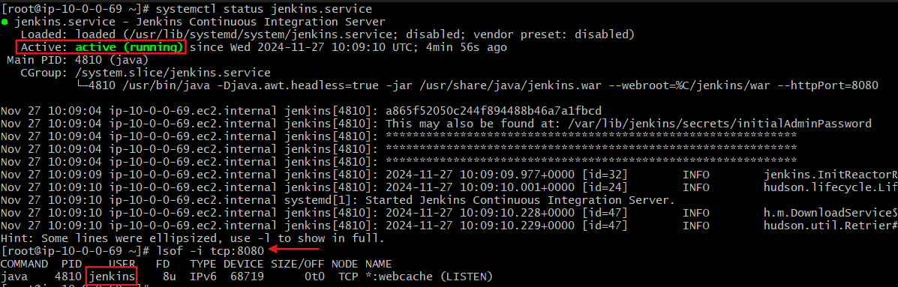

>>changing port no of jenkins to 8081

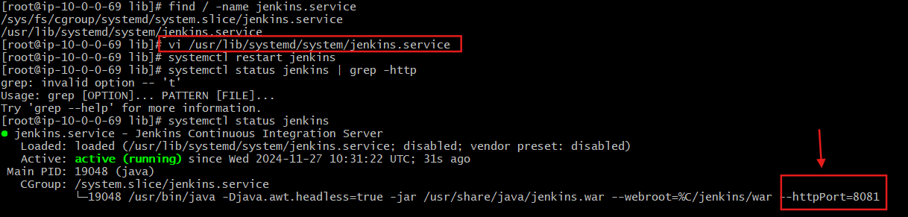

>>checking on web bro

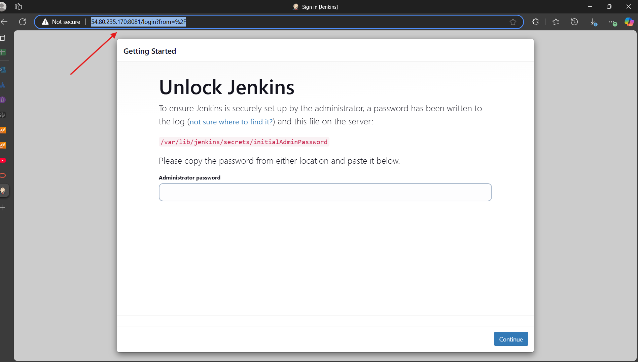

**2) Secure Jenkins server**

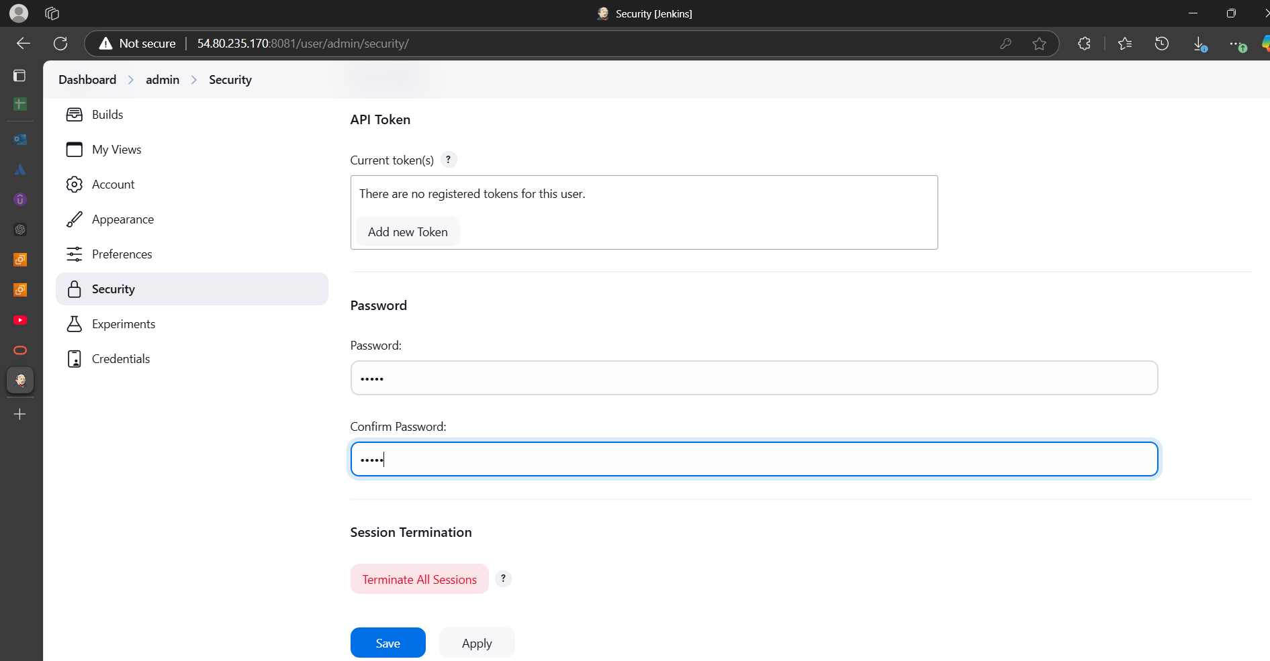

**3) Create users called Devops, Testing in Jenkins with Limited access.**

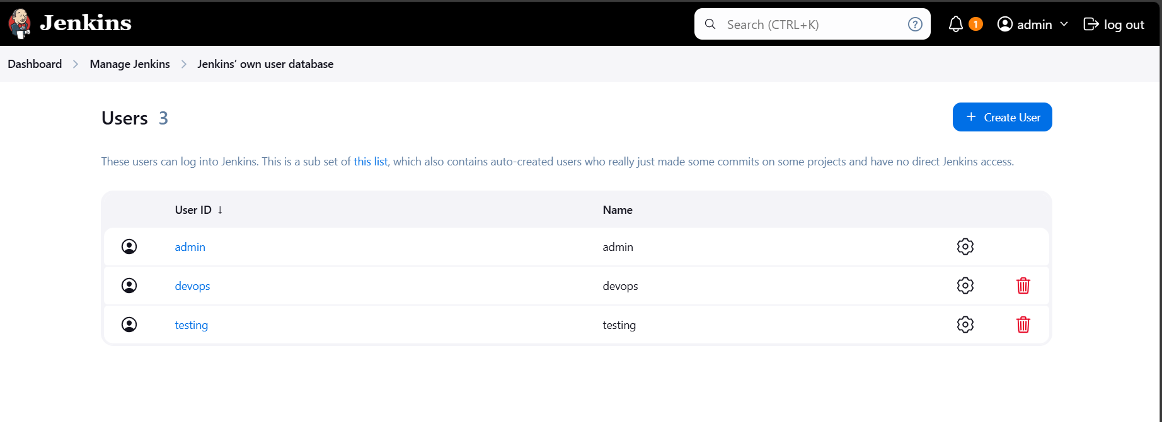



**4) Configure labels and restrict the jobs to execute based on label only.**

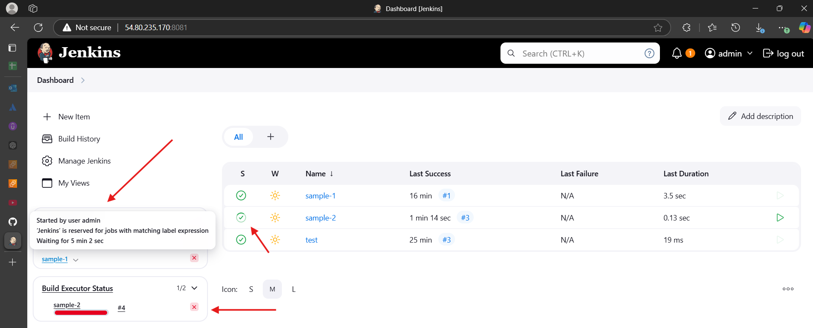

**5) Create Three sample jobs using the below URL.**

**https://github.com/betawins/Techie_horizon_Login_app.git**

